# BASAWESHWAR ENGINEERING COLLEGE

# (AUTONOMOUS),

# BAGALKOTE-587102



## DEPARTMENT OF ELECTRONICS AND COMMUNICATION

## CERTIFICATE

This is to certified to project entitled “QUIZ FOR KIDS” bonafied work of, Ms.Megha C Shirol [2BA21EC042], Ms.Shaila S Dalawai[2BA21EC089]. The report satisfies the academic requirements with respect to project work prescribed for III semester during the academic year 2022-2023. It is certified that all corrections/ suggestions indicated assessment of the project have been satisfied.

## PROJECT GUIDE: HEAD OF THE DEPARTMENT:

## PROF.M.C.ARALIMARAD DR.SHRIDHAR KUNTOJI

## Signature with date:

# BLOCK DIAGRAM..

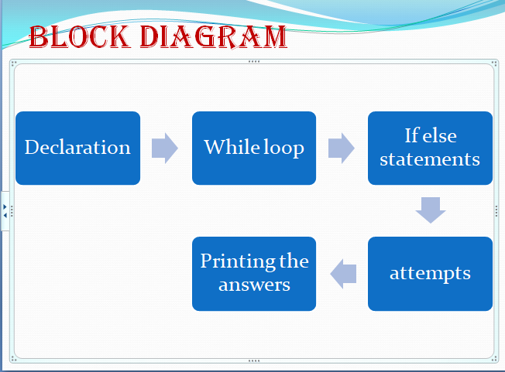

# STATEMENTS AND LIBRARY FUNCTIONS USED AND THEIR SYNTAX

The logic of the program is .......The Quiz game asks the player questions about animals. They have three chances to answer each question you don’t want to take the quiz too difficult. Each correct answer will score a point. At the end of the game, the program will reveal the player’s final score. Now is the time to create your quiz! First, I’ll create the questions and the answer verification mechanism. Next, I’ll add the code that gives the player three attempts to answer each question:

In this code we have used the

* Check_guess function : This function accepts the two arguments. The word guessed by the user and the correct answer . The first is the guessed word and the second is the word the user has to find. check_guess() returns a string containing the following characters:

X for each character in the guess that is at the correct position.

O for each character in the guess that is in the word but not at the correct position.

_ for each character in the guess that is not part of the word. For example, check_guess("birds", "words") should return __XXX.

Syntax: check_guess()

* guess.lower(): this method returns a string where all characters are lower case.

Syntax=lower(text)

# PROJECT CODE (QUIZ FOR KIDS):

def check_guess(guess, answer):

global score

still_guessing = True

attempt = 0

while still_guessing and attempt < 3:

if guess.lower() == answer.lower():

print("Correct Answer")

score = score + 1

still_guessing = False

else:

if attempt < 2:

guess = input("Sorry Wrong Answer, try again")

attempt = attempt + 1

if attempt == 3:

print("The Correct answer is ",answer )

score = 0

print("Guess the Animal")

guess1 = input("Which bear lives at the North Pole? ")

check_guess(guess1, "polar bear")

guess2 = input("Which is the fastest land animal? ")

check_guess(guess2, "Cheetah")

guess3 = input("Which is the larget animal? ")

check_guess(guess3, "Blue Whale")

guess4=input("which is the national animal?")

check_guess(guess4,"tiger")

guess5=input("What is the national bird?")

check_guess(guess5,"Peacock")

guess6=input("Which plant grows without water?")

check_guess(guess6,"Cactus")

guess7=input("Which is the national flower?")

check_guess(guess7,"Lotus")

printf("Your Score is "+ str(score))

print("Your Score is "+ str(score))

# OUTPUT:

Guess the Answer

Which bear lives at the North Pole? polar bear

Correct Answer

Which is the fastest land animal? lion

Sorry Wrong Answer, try againtiger

Sorry Wrong Answer, try againhorse

The Correct answer is Cheetah

Which is the larget animal? elephant

Sorry Wrong Answer, try againblue whale

Correct Answer

which is the national animal?tiger

Correct Answer

What is the national bird?peacock

Correct Answer

Which plant grows without water?cactus

Correct Answer

Which is the national flower?lotus

Correct Answer

Your Score is 6

Your Score is 6

>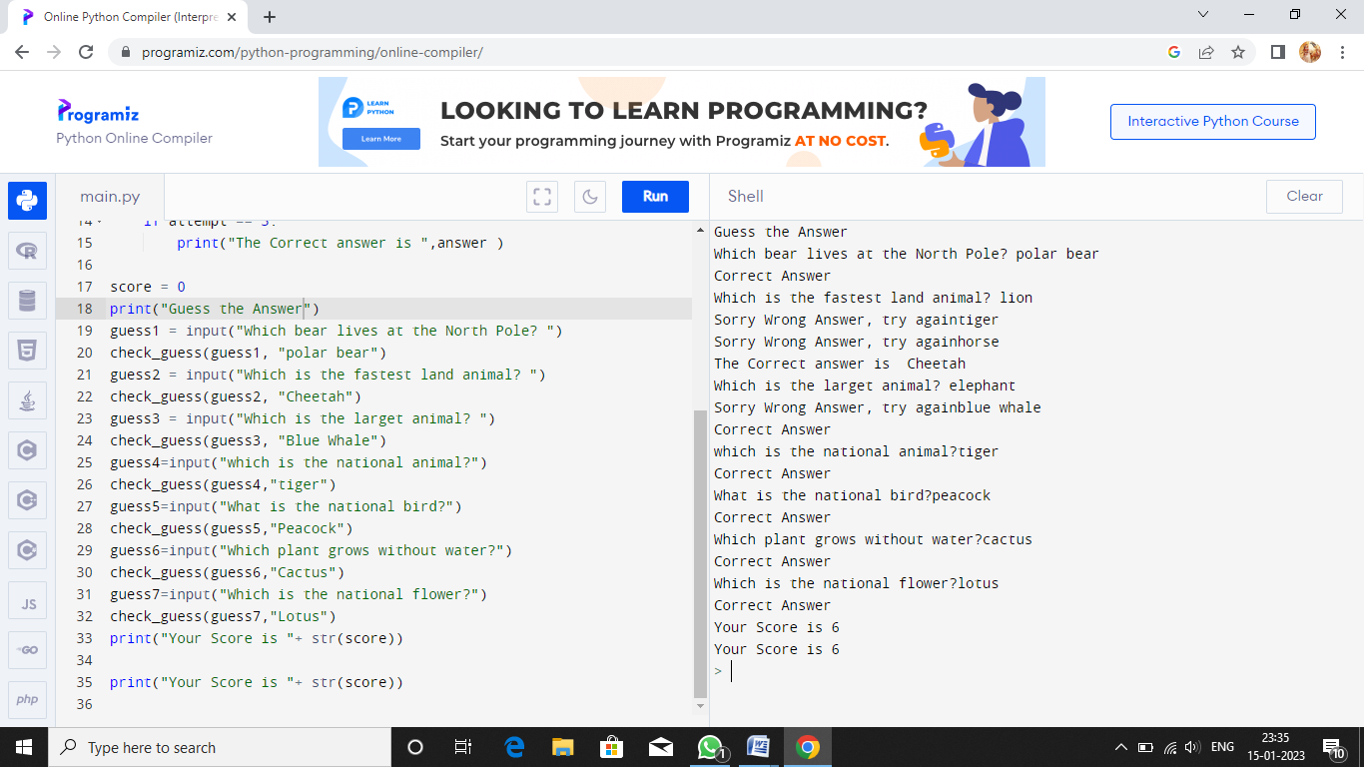

# CONCLUSION:

This quiz game uses a function; a block of code with a name that performs a specific task. A function allows you to use the same code several times, without having to type everything each time. Python has a lot of built-in functions, but it also allows you to create your functions.

The program should continue to check if there are any questions to ask and if the player has exhausted all his chances. The score is stored in a variable during the game. Once all the questions have been answered, the game ends